Pizza Sales SQL Quires

KPI’s

1. Total Revenue

Select SUM(total_price) AS Total_Revenue from pizza_sales;

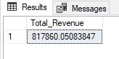

1. Average Order Value

Select Sum(total_price) / COUNT(Distinct order_id) AS avg_order_value from pizza_sales;

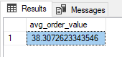

1. Total pizzas sold

Select sum(quantity) AS Total_pizza_sold from pizza_sales;

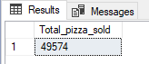

1. Total Order

Select count(distinct order_id) AS Total_orders from pizza_sales;

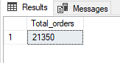

1. Average pizza per order

Select cast(cast(sum(quantity) AS decimal(10,2)) / cast(count(distinct order_id) AS decimal(10,2)) AS decimal(10,2)) AS Avg_pizza_per_order from pizza_sales;

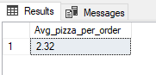

Charts Required

1. Daily trend for total order

Select DATENAME(DW, order_date) AS order_day, count(distinct order_id) as Total_orders from pizza_sales

group by DATENAME(DW, order_date)

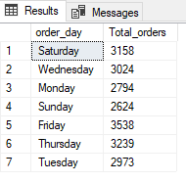

1. Monthly trend for total order

Select DATENAME(MONTH, order_date) AS month_name, Count(Distinct order_id) AS total_orders from pizza_sales

Group by DATENAME(MONTH, order_date) Order by total_orders DESC

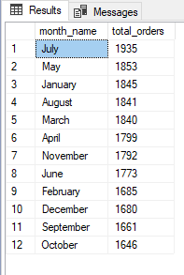

1. % of Sales by Pizza category

Select pizza_category, sum(total_price) * 100 / (Select sum(total_price) from pizza_sales) AS Category_Percentage_Sales from pizza_sales

Group by pizza_category Order by Category_Percentage_Sales DESC

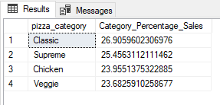

1. % of Sales by pizza size

Overall

Select pizza_size, CAST(sum(total_price) * 100 / (Select sum(total_price) from pizza_sales) AS decimal(10,2)) AS Size_Percentage_Sales from pizza_sales

Group by pizza_size Order by Size_Percentage_Sales DESC

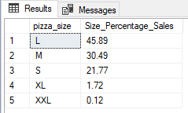

Month wise

Select pizza_size, CAST(sum(total_price) * 100 / (Select sum(total_price) from pizza_sales Where month(order_date) = 1) AS decimal(10,2)) AS Size_Percentage_Sales from pizza_sales

Where month(order_date) = 1

Group by pizza_size Order by Size_Percentage_Sales DESC

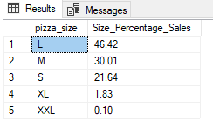

1. Total Pizza sold by pizza category

Select pizza_category, Sum(quantity) AS Total_Pizza_Sold_Category from pizza_sales

group by pizza_category order by Total_Pizza_Sold_Category

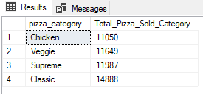

1. Top 5 best sellers by revenue, total quantity and total orders

Total revenue (top 5)

select Top 5 pizza_name, SUM(total_price) AS total_revenue from pizza_sales

group by pizza_name order by total_revenue DESC

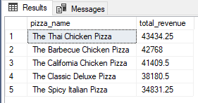

Total Quantity (Top 5)

select Top 5 pizza_name, SUM(quantity) AS total_quantity from pizza_sales

group by pizza_name order by total_quantity DESC

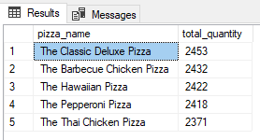

Total Orders (Top 5)

select Top 5 pizza_name, COUNT(distinct order_id) AS total_orders from pizza_sales

group by pizza_name order by total_orders DESC

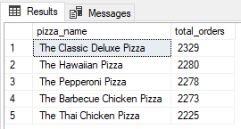

1. Bottom 5 best sellers by revenue, quantity and orders

Total revenue (bottom 5)

select Top 5 pizza_name, SUM(total_price) AS total_revenue from pizza_sales

group by pizza_name order by total_revenue

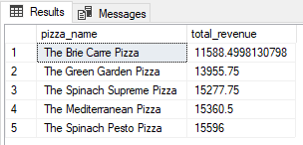

Total quantity (bottom 5)

select Top 5 pizza_name, SUM(quantity) AS total_quantity from pizza_sales

group by pizza_name order by total_quantity

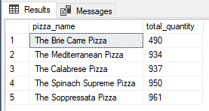

Total Orders (bottom 5)

select Top 5 pizza_name, COUNT(distinct order_id) AS total_orders from pizza_sales

group by pizza_name order by total_orders

